2012 MJC H2 Math (9740) JC 2 Preliminary Exam Paper 1 – Solutions

Qn | Solution
1 | Inequalities



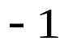

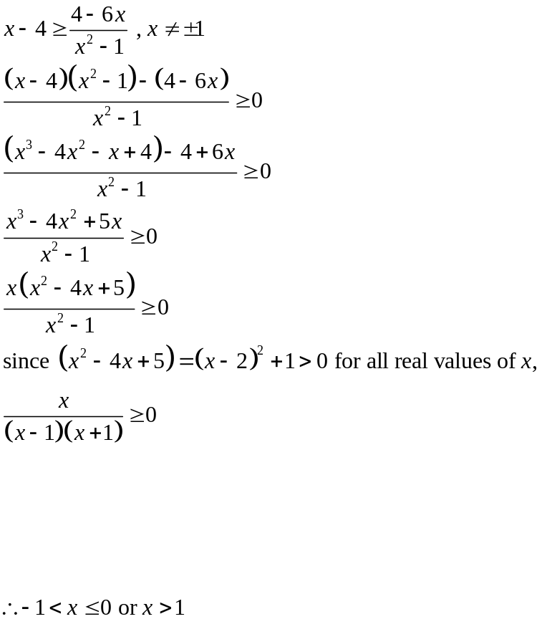

Qn | Solution
2 | SLE
Let 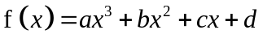.
Method 1:
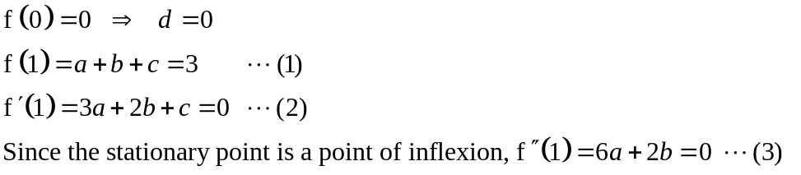
Using GC to solve, a = 3, b = – 9, c = 9
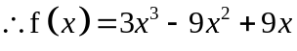
Method 2:
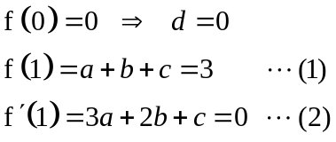
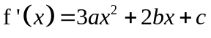
Since there is only one stationary point, 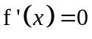 has only one solution.
Hence, Discriminant = 0
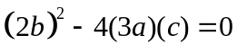
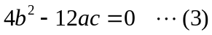
Solving equations (1), (2) & (3), we have 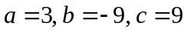

Method 3:
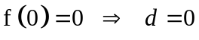
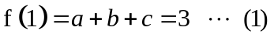
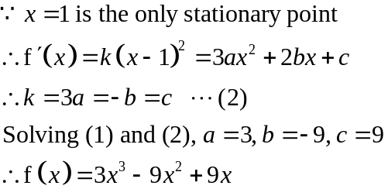

Qn | Solution
3 | Differentiation (Implicit) + Techniques of Integration
(a) | 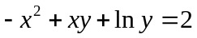  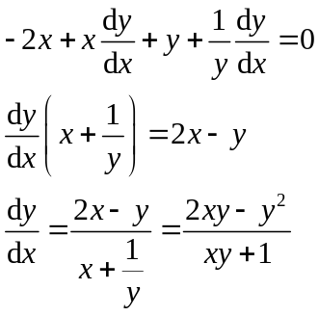
(bi) | 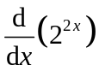=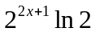
(bii) | 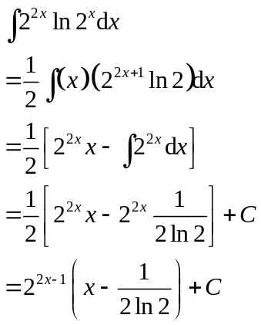

Qn | Solution
4 | Complex 3 (include intersection of loci)
(i) | 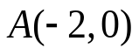  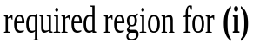    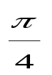        C  ×  4  ○
(ii) | 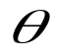  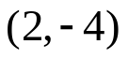  C  ×  8  4  ○  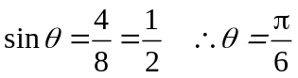  smallest value of 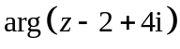 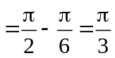
(iii) | Method 1:  AP = 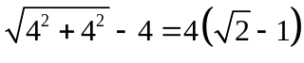  w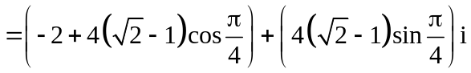 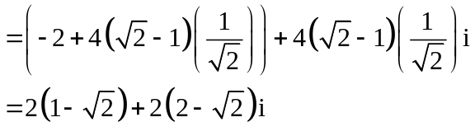  Method 2:  Equation of circle: 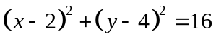-------(1)  Equation of half line: 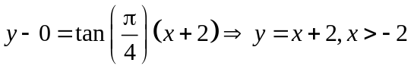----(2)  Sub (2) into (1):  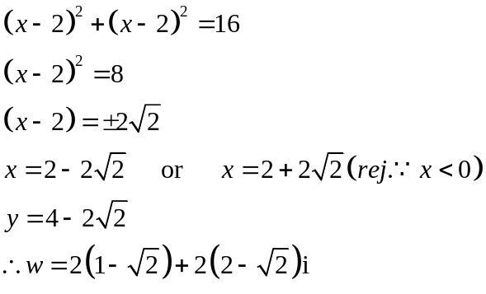        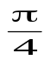  Method 3:  N  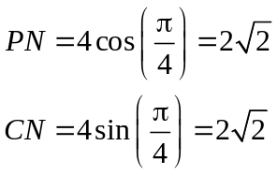  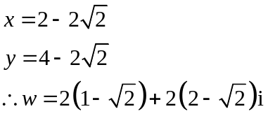

Qn | Solution
5 | Vectors 1 & 2 (Ratio Thm, application of dot & cross product)
(i) | Using ratio theorem,  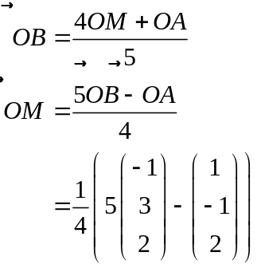  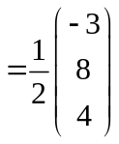
(ii) | 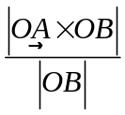represents the shortest/perpendicular distance from point A to the line OB.
(iii) | 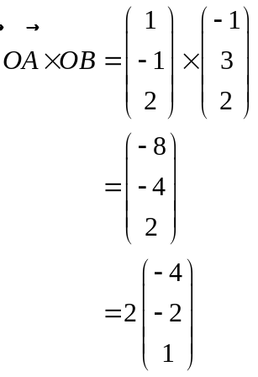  is 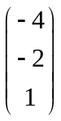.  Method 1:  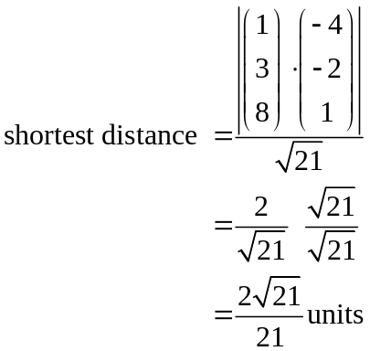  Method 2:  Let N be the foot of perpendicular from C to the plane.  Equation of line CN is 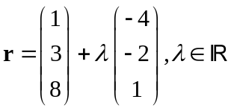  Equation of plane: 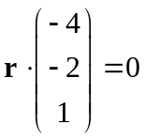  Since N lies on the plane, 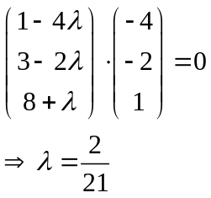  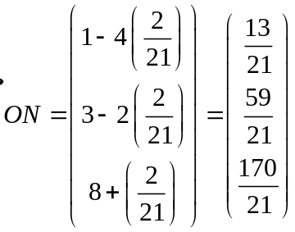  So 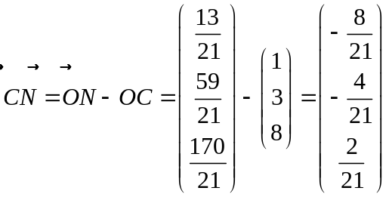  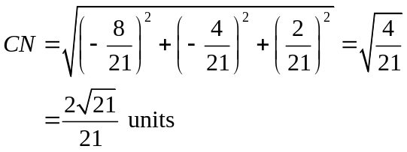

Qn | Solution
6 | Maclaurin + Binomial Series (include concept of approximation)
 | 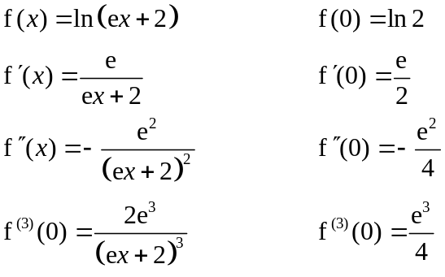
(i) | 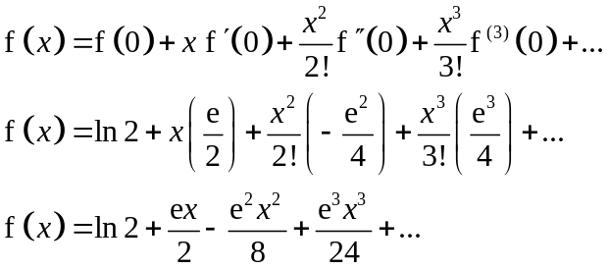
(ii) | 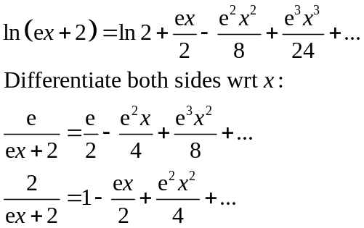
(iii) | 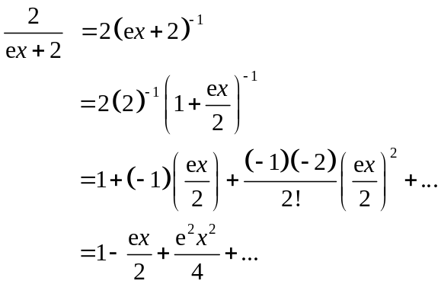

Qn | Solution
7 | MI + Summation
(i) | 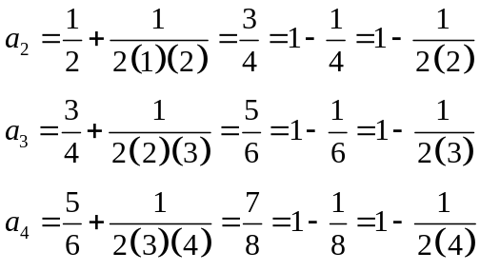  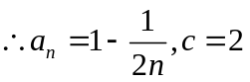
(ii) | Let 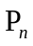 be the statement 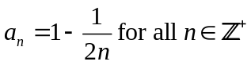.  When ,  LHS = 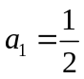  RHS = 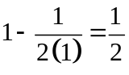  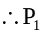 is true  Assume 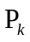 is true for some 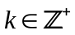, i.e. 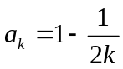.  To prove 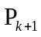 is true. i.e. 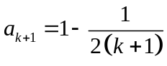  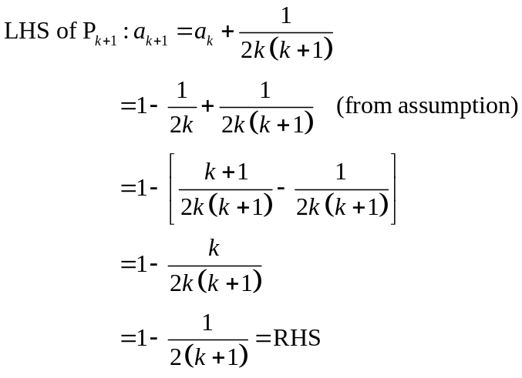  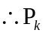 is true 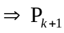 is true  Since 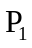 is true and is true is true, by Mathematical Induction, is true for all 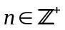.
(iii) | 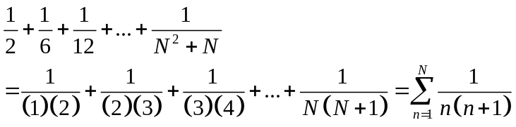  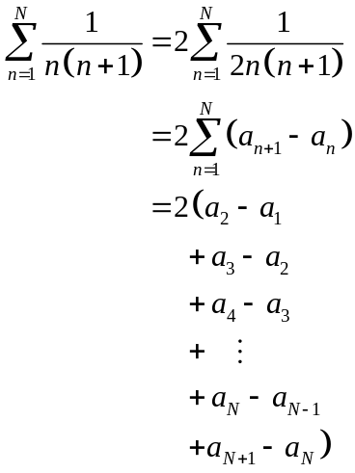  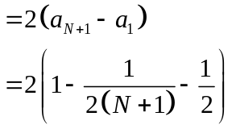  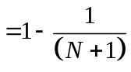

Qn | Solution
8 | Application of Differentiation (Max/Min, Rate of Change)
(i) | Method 1:  Area of triangle PQR = 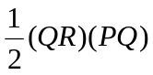 since 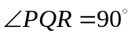 (angle inscribed in a semicircle is a right angle).  Let 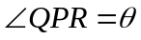.  Then 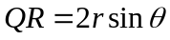 and 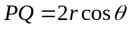  Area of PQR =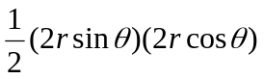  =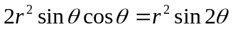.  For maximum area of triangle PQR,  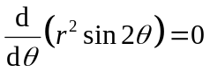  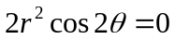  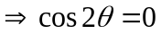  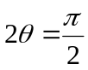  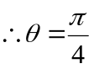  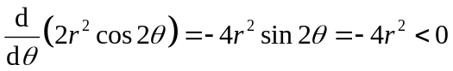 when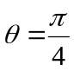  Area is maximum.  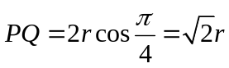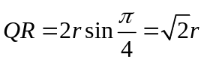  Method 2:  Let 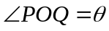.  Area of PQR = Area of POQ + Area of ROQ  = 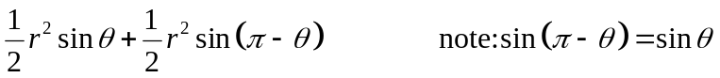  =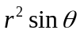.  For maximum area of triangle PQR,  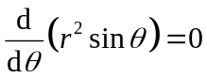  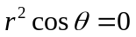  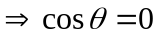  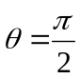  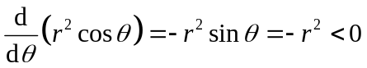 when  Area is maximum.  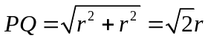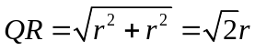  Method 3:  Let the length of PQ be x units.  Let A be the area of triangle PQR  A = 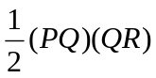 = 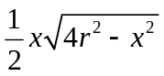  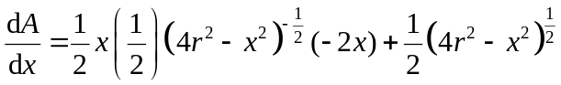  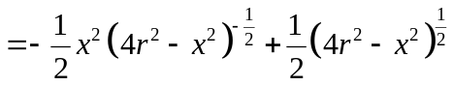  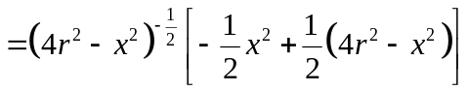  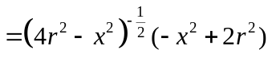  For maximum area of triangle PQR,  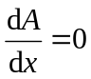  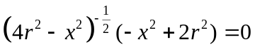  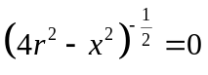 or 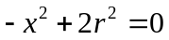  (No solution) 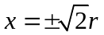  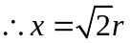  Using 1st derivative test,  Area is maximised when 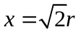  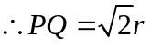  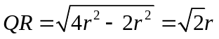
   | 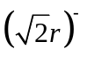 | 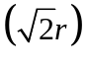 | 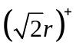
  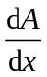
(ii) | For 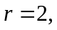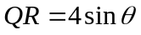  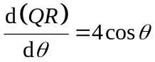  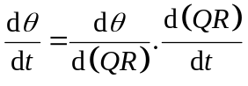  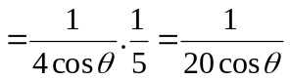  When 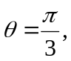  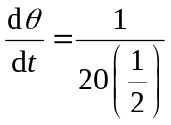  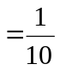 radians per second.

Qn | Solution
9 | Arithmetic and Geometric Progressions
(i) | 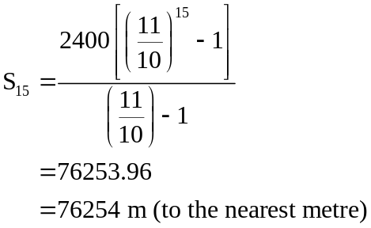
(ii) | 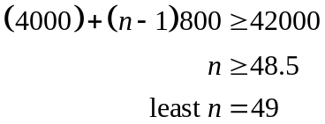  Or  By GC,  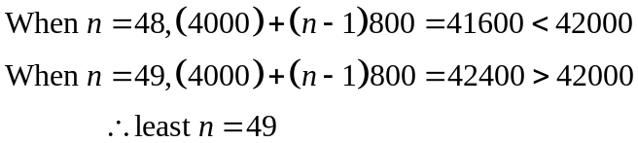
(iii) | Total distance covered by runner B in 3 days  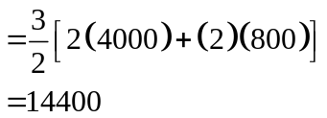  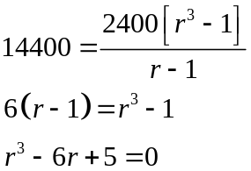  By GC,  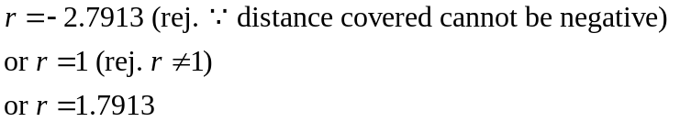  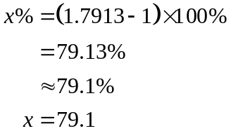

Qn | Solution
10 | Differential Equations
(a) | 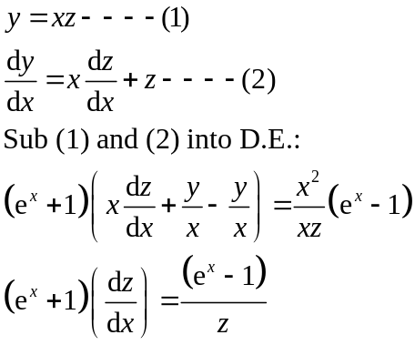  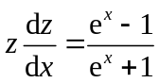  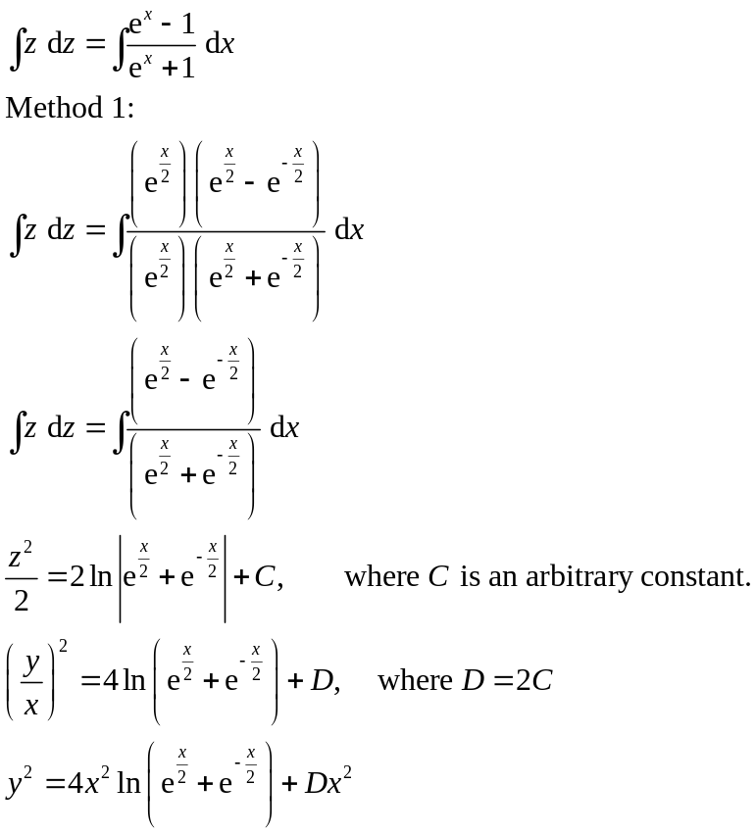  Method 2:  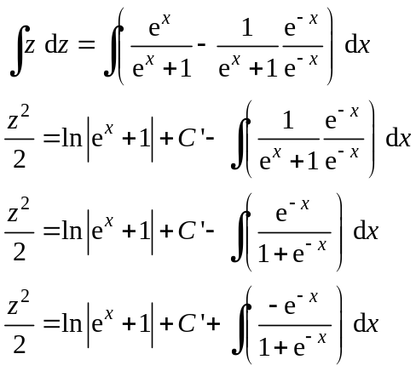  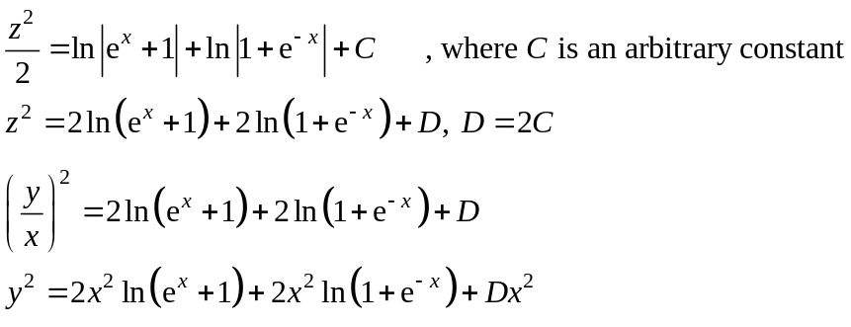  Method 3:  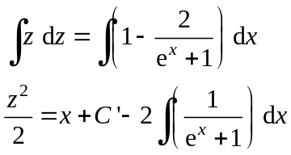  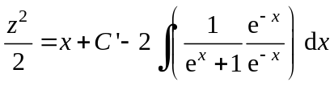  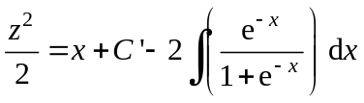  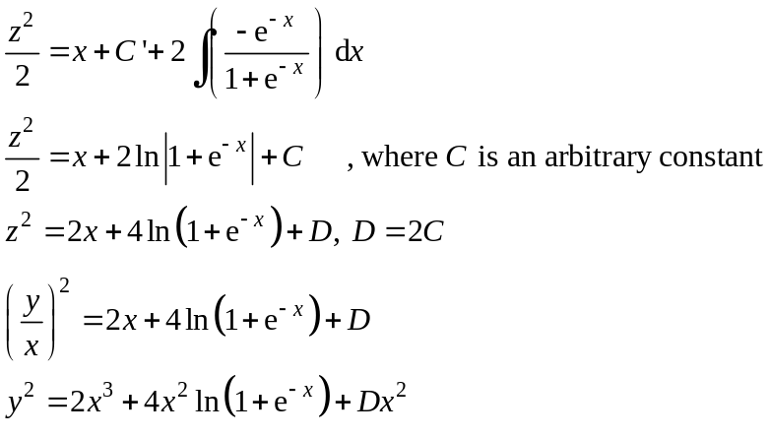  Method 4:  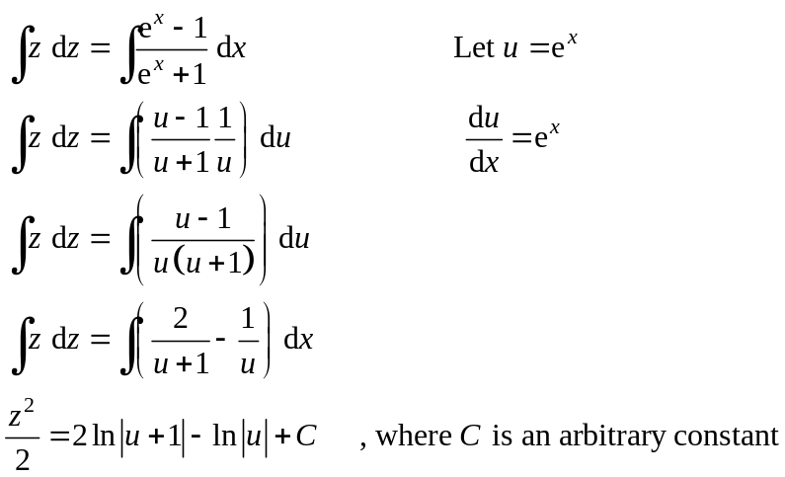  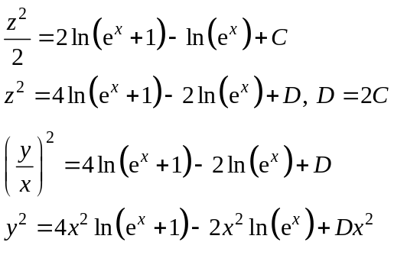
(b) | 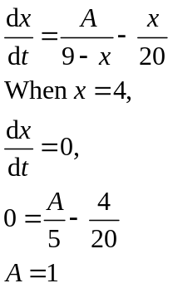
 | 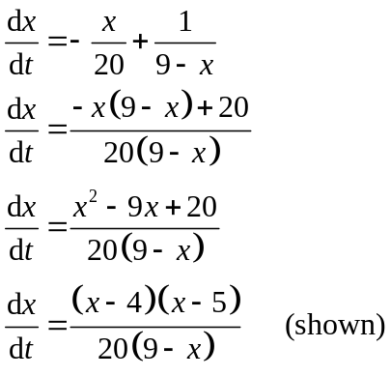
 | 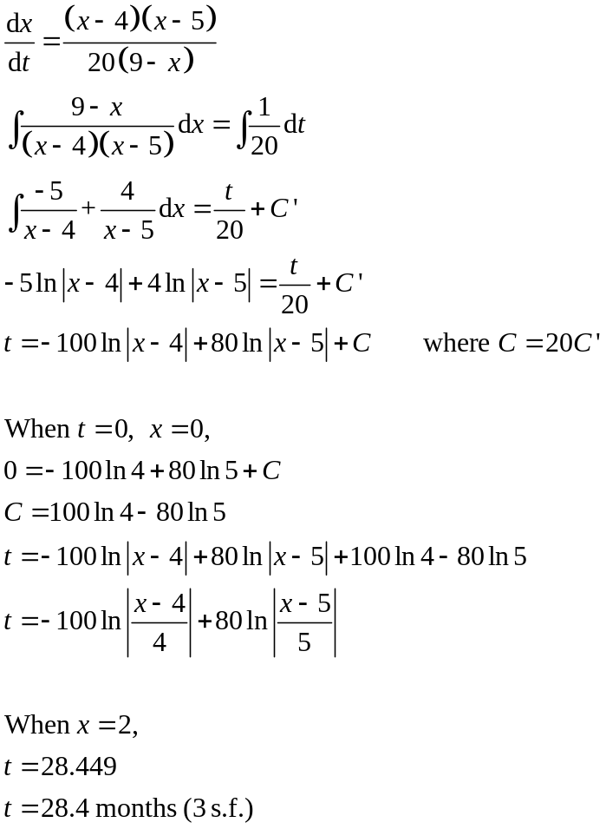
Qn | Solution
11 | Complex no. 1-3 (Roots + Loci)
(i) | 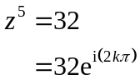  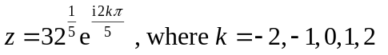  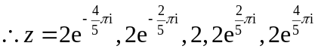
(iii) | 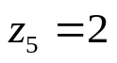  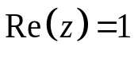  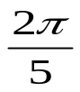  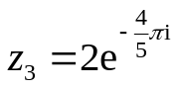  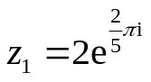  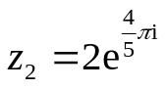  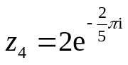  2  Locus of  Re  Im  There are 4 points within the region given.
(iii) | Im  Locus of  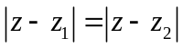  z  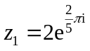  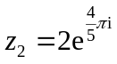  Re  2  Locus of  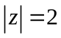  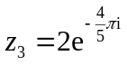  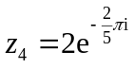  Method 1:  Since the argument of 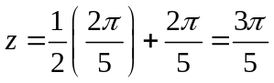 or 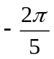,  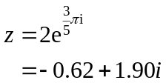 or 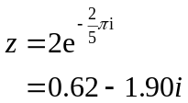  Method 2:  Equation of circle centred 0+0i and radius 2: 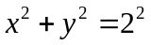  Gradient of the perpendicular bisector = 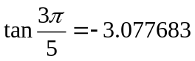  Equation of perpendicular bisector that passes through the Origin:  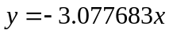  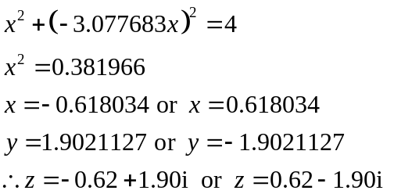
(iv) | Method 1:  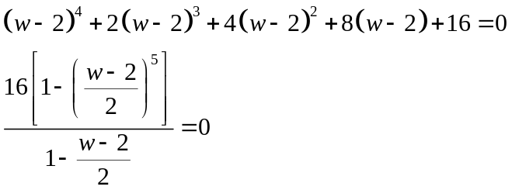  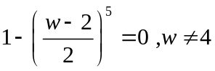  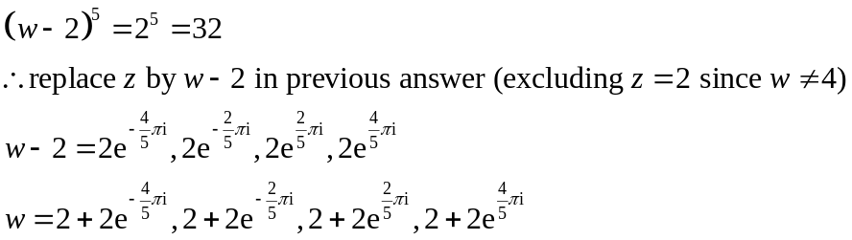  Method 2:  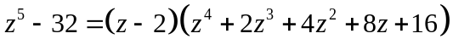  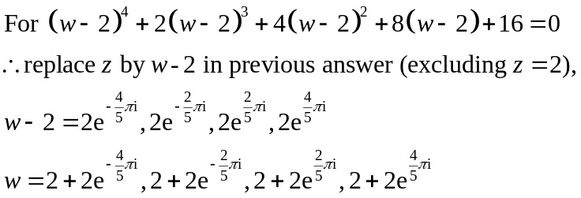  ------------------------------------------------------------------------------------  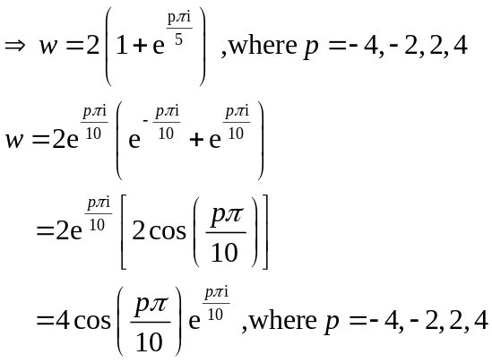

Qn | Solution
12 | Curve Sketching + Transformations + Integration
a(i) | Method 1  1. Translation of 1 unit in the direction of x–axis.  2. Scaling parallel to the x–axis by factor .  3. Scaling parallel to the y-axis by factor .  Method 2  1. Scaling parallel to the y-axis by factor .  2. Scaling parallel to the x-axis by factor  3. Translation of unit in the direction of x–axis.
(ii) | Area 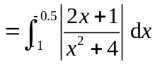  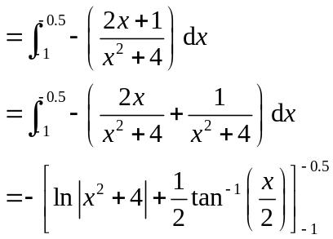  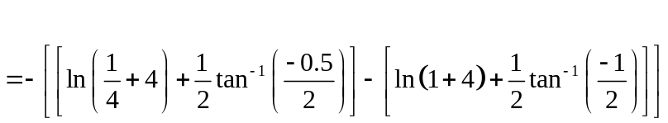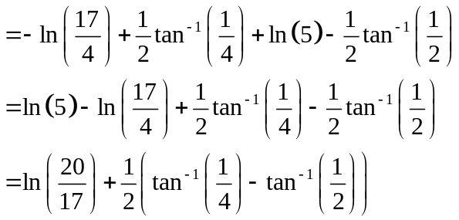

(b) | 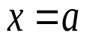  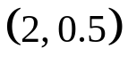  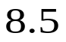  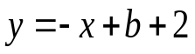  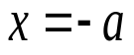  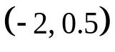  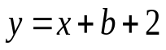  (i)  y  x  O  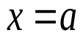  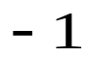  (ii) 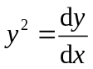  y  x  2  O

